Subject :- Data science with R programming
Lab project :- Airline Passenger Satisfaction
Kaggle Link: https://www.kaggle.com/datasets/teejmahal20/airline-passenger-satisfaction Details: Size: ~130K rows | Domain: Aviation
Phase 1 — Data Cleaning
- Find the column(s) with missing values and handle them appropriately.

Load Dataset
df <- read.csv("dataset.csv")
head(df)
# Check Missing Values
colSums(is.na(df))
# Usually, 'Arrival Delay in Minutes' has NAs; we'll fill them with 0 or the median
df <- df %>% mutate(Arrival.Delay.in.Minutes = replace_na(Arrival.Delay.in.Minutes, 0))
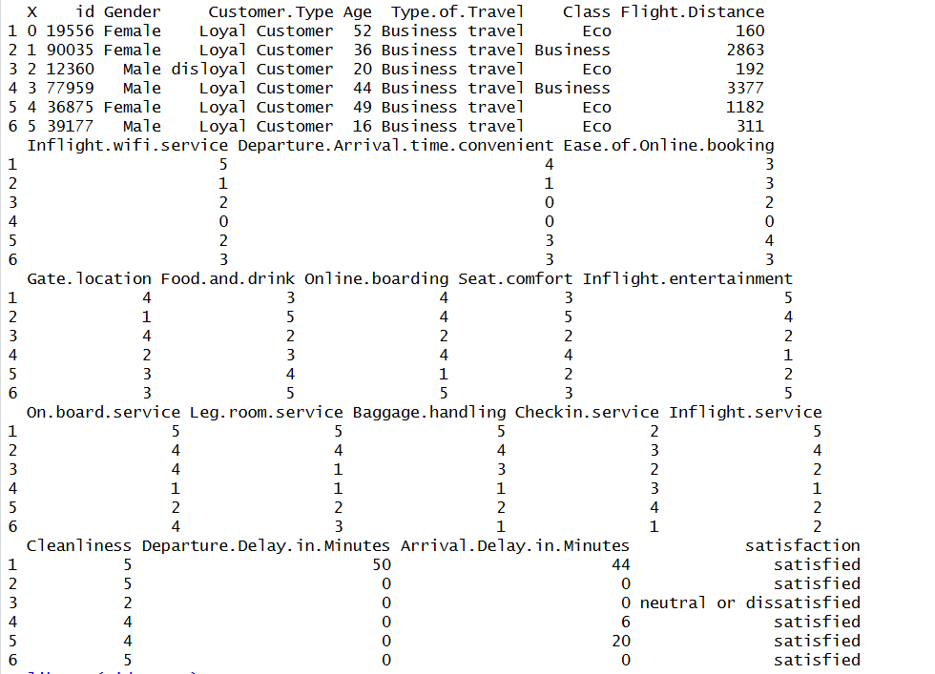
- Encode the target column satisfaction as binary (satisfied = 1, neutral/dissatisfied = 0).

# 2. Encode target column 'satisfaction' as binary
df <- df %>% mutate(satisfaction = ifelse(satisfaction == "satisfied", 1, 0))

- Check for class imbalance in the target variable and report the ratio.

# 3. Check for class imbalance
prop.table(table(df$satisfaction))

- Remove irrelevant columns like Unnamed: 0 and id.

# 4. Remove irrelevant columns
df <- df %>% select(-X, -id)

- Normalize rating columns (scale 0-5) using Min-Max Scaling.

# 5. Normalize rating columns (scale 0-5) using Min-Max Scaling
# Formula: (x - min) / (max - min)
normalize <- function(x) { return((x - 0) / (5 - 0)) }
rating_cols <- c("Inflight.wifi.service", "Departure.Arrival.time.convenient",
"Ease.of.Online.booking", "Gate.location", "Food.and.drink",
"Online.boarding", "Seat.comfort", "Inflight.entertainment",
"On.board.service", "Leg.room.service", "Baggage.handling",
"Checkin.service", "Inflight.service", "Cleanliness")

df[rating_cols] <- lapply(df[rating_cols], normalize)

Phase 2 — Exploratory Data Analysis (EDA)

- What percentage of passengers are satisfied vs neutral/dissatisfied?

# 1. Percentage of passengers satisfied
df %>% count(satisfaction) %>% mutate(pct = n / sum(n) * 100)

- What is the average age of passengers? How does it differ by travel class?

# 2. Average age by travel class
df %>% group_by(Class) %>% summarise(avg_age = mean(Age, na.rm = TRUE))

- Which service column (WiFi, Food, Seat Comfort, etc.) has the lowest average rating?

# 3. Lowest average rating service column
df %>% summarise(across(all_of(rating_cols), mean)) %>%
pivot_longer(everything()) %>% arrange(value)

- What is the average Departure Delay and Arrival Delay? How many flights had 0 delay?

# 4. Average Delays and 0 delay count
mean(df$Departure.Delay.in.Minutes)
mean(df$Arrival.Delay.in.Minutes)
sum(df$Departure.Delay.in.Minutes == 0)

- Use groupby('Class')['satisfaction'].mean() to compare satisfaction across classes.

# 5. Satisfaction across classes
df %>% group_by(Class) %>% summarise(satisfaction_rate = mean(satisfaction))

- Are loyal customers more satisfied than disloyal ones? Compute and compare percentages.

# 6. Loyal vs Disloyal satisfaction
df %>% group_by(Customer.Type) %>% summarise(satisfaction_rate = mean(satisfaction))

Phase 3 — Graphical Reports
- Plot satisfaction rate by Customer Type (Loyal vs Disloyal) using a bar chart.

# 1. Satisfaction rate by Customer Type (Bar Chart)
ggplot(df, aes(x = Customer.Type, fill = as.factor(satisfaction))) +
geom_bar(position = "fill") +
labs(y = "Proportion", title = "Satisfaction by Customer Loyalty")

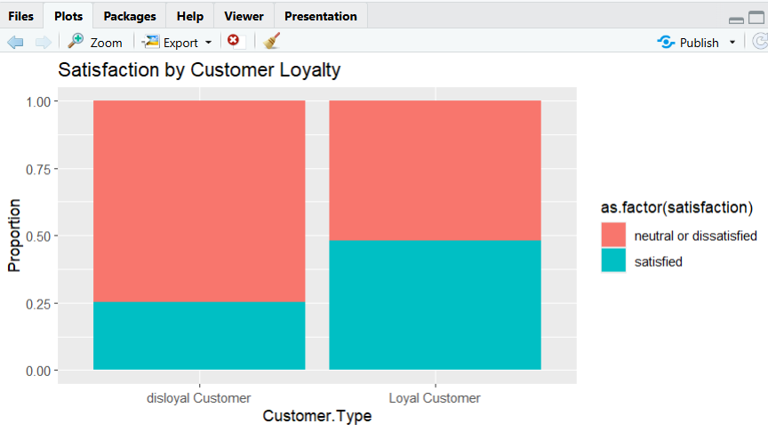

- Show satisfaction by Class (Business / Eco / Eco Plus) using a grouped bar chart.
# 2. Satisfaction by Class (Grouped Bar Chart)
ggplot(df, aes(x = Class, fill = as.factor(satisfaction))) +
geom_bar(position = "dodge") +
labs(title = "Count of Satisfaction Levels by Class")

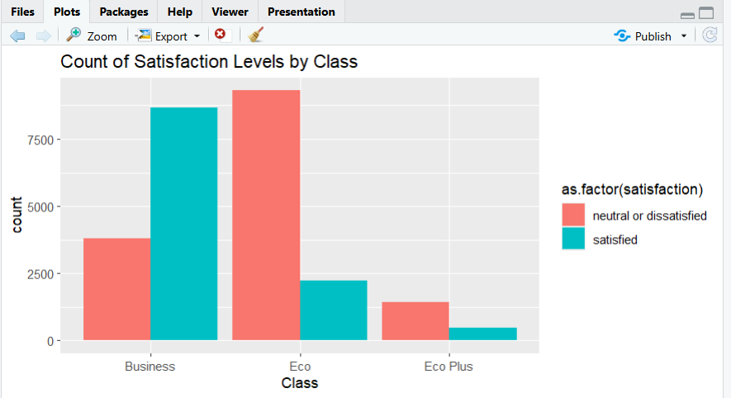

- Create a heatmap of all service rating columns to find which services are most correlated.

# 3. Heatmap of correlations
library(reshape2)
cor_matrix <- cor(df[rating_cols])
melted_cor <- melt(cor_matrix)
ggplot(melted_cor, aes(Var1, Var2, fill = value)) +
geom_tile() +
scale_fill_gradient2(low = "blue", high = "red", mid = "white") +
theme(axis.text.x = element_text(angle = 45, hjust = 1))

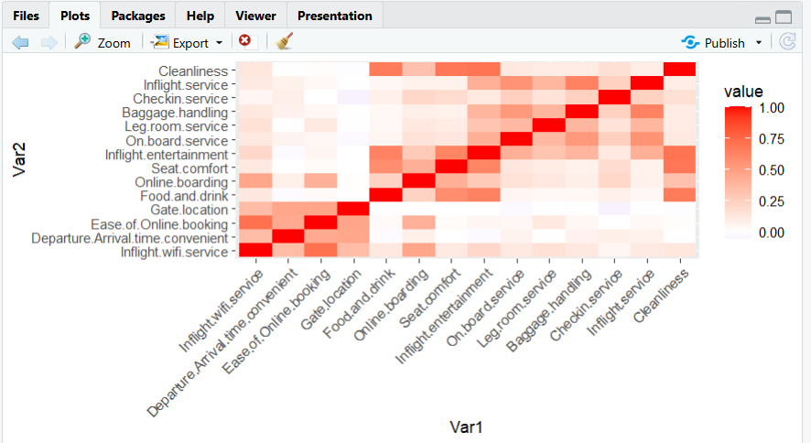
- Plot the distribution of Flight Distance for satisfied vs dissatisfied passengers.

# 4. Distribution of Flight Distance
ggplot(df, aes(x = Flight.Distance, fill = as.factor(satisfaction))) +
geom_density(alpha = 0.5) +
labs(title = "Flight Distance Distribution by Satisfaction")

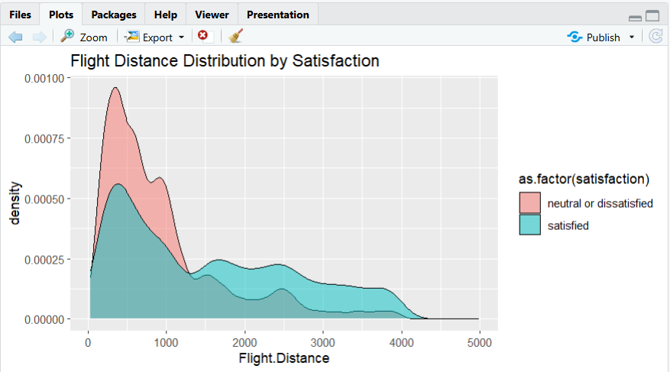

Phase 4 — Business Decisions
Based on the code output above, you can answer the final questions:

- Investment: Look at the result of Phase 2, Q3. Whichever service has the lowest mean (likely Wifi or Food) is where the airline should invest.

- Pricing: If Phase 2, Q5 shows Business Class has significantly higher satisfaction (which it usually does in this dataset), it suggests that premium pricing is justified by a better experience, but Economy needs service improvements to justify its cost.

- Delays: Use the correlation or a scatter plot between Arrival.Delay.in.Minutes and satisfaction. Usually, delays over 30-60 minutes show a sharp drop in satisfaction levels.

